**AUTOMATIC PLANT IRRIGATION SYSTEM**

A MINI PROJECT REPORT SUBMITTED TO THE

DEPARTMENT OF COMPUTER APPLICATIONS, BHARATHIAR UNIVERSITY

IN PARTIAL FULFILMENT OF THE REQUIREMENT FOR

THE AWARD OF THE

DEGREE OF

**MASTER OF COMPUTER APPLICATIONS**

Submitted by

**D. NAVEENKUMAR**

**(REG.NO.22CSEA21)**

UNDER THE GUIDANCE OF

**Mr. K. MOORTHY MCA.,**

**Department of Computer Applications**



**DEPARTMENT OF COMPUTER APPLICATIONS**

**BHARATHIAR UNIVERSITY**

**COIMBATORE-641046**

**DECEMBER – 2023**

##### CERTIFICATE

This is certify that, this mini-project work titled “AUTOMATIC PLANT IRRIGATION SYSYTEM”, submitted to Bharathiar University in a partial fulfillment for the award of the degree of **MASTER OF COMPUTER APPLICATIONS**, is a record of original work done by **NAVEENKUMAR .D (22CSEA21)**,during his period of study in the Department of Computer Applications, Bharathiar University, Coimbatore, under my supervision and guidance, and this mini- project work has not formed the basis for the award of any Degree/Diploma /Associateship/ Fellowship or similar title to any candidate of any university.

Place: Coimbatore

Date:

Mini-Project Guide Mini-Project Guide Head of the Department

Submitted for the Mini-project VIVA-VOICE Examination held on:-

Internal Examiner External Examiner

##### DECLARATION

I hereby declare that , this mini-project work titled” **AUTOMATIC PLANT IRRIGATION SYSTEM**” , submitted to Department of Computer Applications, Bharathiar University, is a record of original work done by **NAVEENKUMAR.D (22CSEA21)**, under my supervision and guidance of **Mr. K. MOORTHY MCA,** Department of computer Applications, Bharathiar University, and this mini- project work has not formed the basis for the award of any Degree/Diploma /Associateship/ Fellowship or similar title to any candidate of any university.

Place: Coimbatore Signature of the candidate

Date:

##### ACKNOWLEDGEMENT

I have taken efforts in this project. However, it would not have been possible without the kind support and help of many individuals and organizations. I would like to extend my sincere thanks to all of them.

I express my sincere gratitude to our Professor& Head of the Department **Dr. M.PUNITHAVALLI, M.Sc., M.Phil., Ph.D.,** Department of Computer Application, Bharathiar University, Coimbatore, thanks to department faculty members and guest faculties supported to acquire knowledge from various inputs. I am forever indebted to this mini project guides **Mr. K. MOORTHY MCA.,** Department of Computer Applications, Bharathiar University for providing valuable suggestions and always been enthusiastically guiding us throughout the project.

Finally, I also extend my special thanks to my family, friends, who have kindly provided the necessary support for the successful completion of the project and their moral support.

## ABSTRACT

Nowadays, Embedded System technology has witnessed rapid growth, opening avenues for innovative solutions. Our project focuses on an Automatic Plant Watering System, employing the latest ARDUINO microcontroller technology. The primary goal of this project is to enhance plant care by automating the watering process, addressing the challenges faced by plant enthusiasts. Maintaining optimal soil moisture levels is crucial for plant health, and this system aims to achieve this seamlessly. Utilizing ARDUINO as the core technology, the system incorporates soil moisture sensors strategically placed in the plant's environment. These sensors continuously monitor the soil's moisture content, ensuring an accurate assessment of the plant's hydration needs.

The key objectives include automating the watering process based on real-time moisture levels, thereby providing a consistent and tailored watering regimen. The system is designed to dispense water precisely when needed, preventing over-watering or under-watering scenarios. The user-friendly interface allows plant enthusiasts to customize watering schedules and set moisture thresholds according to specific plant requirements. The system further enhances user convenience by providing real-time feedback on soil moisture levels through a dedicated LCD display. In addition to the automation aspect, the project incorporates safety features to prevent water wastage and ensure the longevity of the system. The automatic plant watering system aims to promote sustainable and efficient plant care practices, catering to both novice and experienced gardeners.

By leveraging embedded system principles and the power of ARDUINO microcontrollers, our project seeks to revolutionize plant care, making it accessible, efficient, and environmentally conscious.

**TABLE OF CONTENTS**

|  |  |  |
| --- | --- | --- |
| **S.NO** | **TITLE** | **PAGE NO** |
| 1 | INTRODUCTION |  |
|  | 1.1 Purpose of IOT |  |
| 2 | ARDUINO INSTALLATION AND CONFIGURATION |  |
| 3 | BASIC COMPONENTS |  |
|  | 3.1 Arduino UNO |  |
|  | 3.2 Soil Moisture Sensor |  |
|  | 3.3 Jumper Cable |  |
|  | 3.4 Bread Board |  |
|  | 3.5 Arduino Uno Cable |  |
|  | 3.6 Relay |  |
|  | 3.7 5v Submersible Water Pump |  |
|  | 3.8 16*2 LCD Display |  |
| 4 | PROJECT DISCRIPTION |  |
|  | Component Connection |  |
| 5 | WORKING PRINCIPLES |  |
| 6 | RESULT &OUTPUT |  |
| 7 | CODINGS |  |
| 8 | CONCLUSION |  |
| 9 | REFERENCE |  |

INTRODUCTION

## INTRODUCTION

In the realm of horticulture, our focus is on the creation of a groundbreaking Automatic Plant Watering System. This innovative system leverages cutting-edge technology to redefine the way we care for our plants, offering an intelligent and automated solution for plant enthusiasts.

At the heart of this project is the ARDUINO microcontroller, orchestrating a sophisticated network of sensors designed to monitor and respond to the unique moisture requirements of plants. Soil moisture sensors are strategically placed within the planting environment, continuously collecting real-time data on the hydration status of the soil.

The core objective is to revolutionize plant care by automating the watering process based on precise and dynamic soil moisture levels. By translating moisture data into actionable insights, the system ensures that plants receive optimal hydration, mitigating the risks of overwatering or dehydration.

User interaction is seamlessly integrated, allowing enthusiasts to customize watering schedules and set moisture thresholds to align with specific plant needs. The system further enhances the user experience through a comprehensive interface, providing instant feedback on soil moisture levels via an intuitive LCD display.

Beyond the automation aspect, the project aims to foster sustainable gardening practices. The implementation of safety features not only prevents water wastage but also promotes the long-term health of both plants and the environment.

The Intelligent Plant Care System seeks to empower plant enthusiasts, regardless of their gardening expertise, by providing a user-friendly and efficient solution for nurturing healthy, vibrant plants. By embracing embedded system principles, this project envisions a future where plant care is not only accessible but also environmentally conscious.

## 1.1 PURPOSE OF IOT

The essence of IoT lies in connecting devices embedded in various systems to the internet, and the Automatic Plant Watering System seamlessly integrates this concept into the realm of plant care.

This connectivity facilitates the collection of extensive data, contributing to enhanced efficiency, safety, and security in plant care through IoT principles.

Industries spanning utilities, oil & gas, insurance, manufacturing, transportation, infrastructure, and retail can harness the benefits of IoT by leveraging the wealth of interactive and transactional data at their disposal. In the domain of plant care, this translates to more informed decisions and improved agricultural practices.

Robust IoT platforms empower Automatic Plant Watering Systems to discern valuable information, enabling precise decision-making. This information is instrumental in detecting patterns, providing recommendations, and anticipating potential issues before they manifest.

IoT transforms plant care, making it more intelligent and efficient. The system not only automates the watering process but also evolves into a sophisticated tool for data-driven decision-making in agriculture.

While IoT has already revolutionized plant care, this is just the beginning. The full potential of IoT in the context of an Automatic Plant Watering System necessitates a comprehensive understanding of the opportunities for value creation and a systematic approach to address underlying challenges.

From residential gardens to industrial agriculture, the Internet of Things has become an integral part of plant care, connecting everything and everyone involved in cultivating a greener and more sustainable world.

##### BASIC COMPONENTS

**2.1 ARDUINO IDE:**

The Arduino Integrated Development Environment - or Arduino Software (IDE) -connects to the Arduino boards to upload programs and communicate with them. Programs written using Arduino Software (IDE) are called sketches.

**Downloading and installing the Arduino IDE 2.0**

In this tutorial, we will show how to download and install the Arduino IDE 2.0 on your Windows, Mac, or Linux computer.

Requirements

* **Windows** - Win 11 and newer, 64 bits
* **Linux** - 64 bits
* **Mac OS X** - Version 10.14: "Mojave" or newer, 64 bits

The Arduino IDE 2.0

The Arduino IDE 2.0 is an open-source project. It is a big step from its sturdy predecessor, Arduino IDE 1.x, and comes with revamped UI, improved board & library manager, debugger, autocomplete feature and much more.

Download the Editor

Downloading the Arduino IDE 2.0 is done through the [Arduino Software page](https://www.arduino.cc/en/software). Here you will also find information on the other editors available to use.

Installation

Windows:

To install the software page.Arduino IDE 2.0 on a Windows computer, simply run the file downloaded from the

Installation process of Arduino IDE:

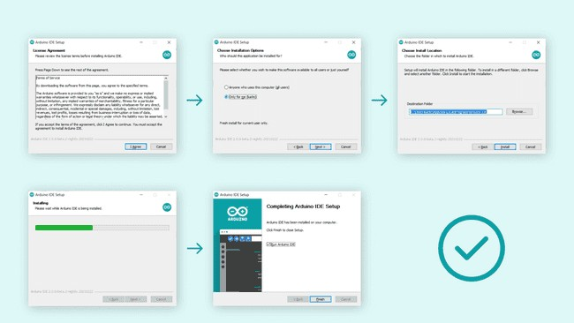

After installation Arduino look like below:

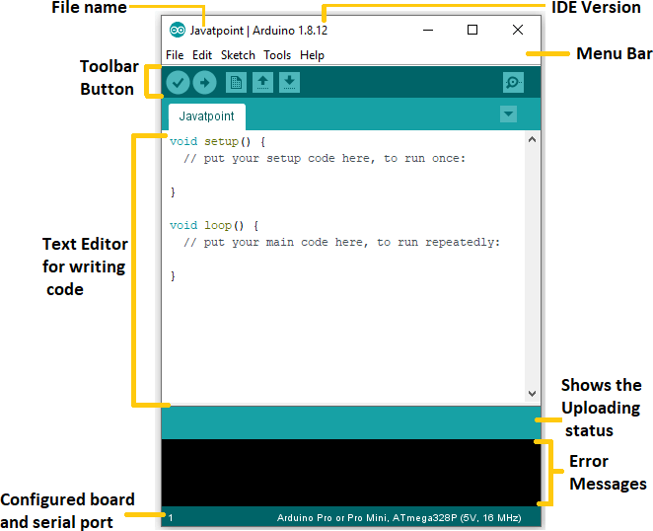

**2.2 ARDUINO UNO**

The Arduino Uno is a versatile microcontroller board based on the ATmega328P. It serves as an excellent platform for various electronics projects and educational purposes.

**Key Features:**

* 14 digital input/output pins (6 of which support PWM output)
* 6 analog inputs for sensor interfacing
* On-board resonator for precise timing
* Reset button for convenient board control
* Holes for mounting pin headers, offering flexibility in connectivity

**Communication and Power:**

A six-pin header allows connection to an FTDI cable or SparkFun breakout board, facilitating USB power and communication.

**Installation and Connectivity:**

The Arduino Uno is well-suited for semi-permanent installations in objects or exhibitions. The absence of pre-mounted headers provides users the flexibility to employ various connectors or directly solder wires, tailoring the board to specific project requirements.

**Voltage and Frequency Options:**

Two versions of the Arduino Uno are available to cater to diverse project needs:

* 3.3V and 8 MHz
* 5V and 16 MHz

 (Arduino UNO)

# 2.3 SOIL MOISTURE SENSOR:

# The soil moisture sensor operates by measuring the volumetric water content in the soil. It utilizes two essential components for this process. The sensor has a pair of electrodes, one acting as a positive probe, and the other as a negative probe. When inserted into the soil, these electrodes create an electrical circuit.

# The soil's moisture content affects the electrical conductivity between the two electrodes. As the soil becomes more conductive due to increased moisture, the sensor detects changes in the resistance across the electrodes. This resistance variation is then translated into a soil moisture reading.

# The sensor typically consists of four pins:

# VCC: This pin supplies power to the sensor.

# GND (Ground): Connects to the ground reference.

# D0 (Digital Output): Provides a digital signal indicating whether the soil moisture surpasses a predefined threshold.

# A0 (Analog Output): Outputs an analog signal corresponding to the actual soil moisture level.

# 

# **(Soil Moisture Sensors)**

## ****Soil Moisture Sensors Work:****

## **The soil moisture sensor functions by gauging the moisture level in the soil, providing valuable data for efficient plant care. Comprising a pair of electrodes, one acting as a positive probe and the other as a negative probe, the sensor is inserted into the soil, creating an electrical circuit. As soil moisture increases, electrical conductivity rises, altering the resistance between the electrodes.**

## **This variation in resistance is then translated into a soil moisture reading. The sensor typically features four pins: VCC for power supply, GND for ground reference, D0 for a digital signal indicating moisture threshold surpassing, and A0 for an analog signal correlating with the actual soil moisture level.**

## **The resulting data proves instrumental for precise irrigation, allowing for tailored watering schedules based on real-time soil conditions. In essence, the soil moisture sensor is a vital tool for optimizing plant growth and conserving water resources.**

## 2.4 JUMPER CABLES:

Jumper wires are simply wires that have connector pins at each end, allowing them to be used to connect two points to each other without soldering.

Jumper wires are typically used with breadboards and other prototyping tools in order to make it easy to change a circuit as needed. Fairly simple.Connecting Jumper Wires to Arduino is very easy. To test your jumper wire with Arduino you can connect one end of a Male to Male jumper wire to Vcc and other end to Pin #13. If the inbuild LED glows, it means the wire is able to conduct properly.

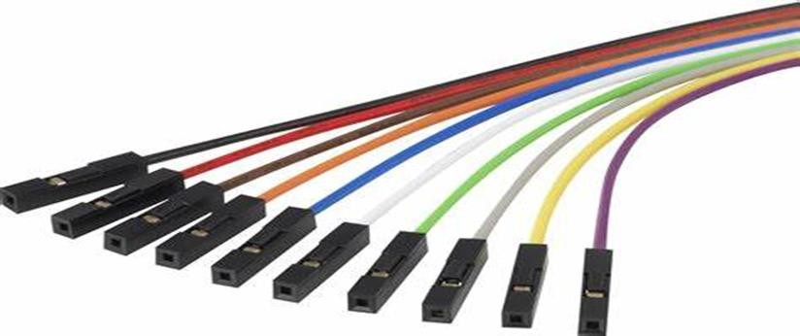

### (jumper wires)

##### Types of jumper cables:

* Male to Male
* Male to female
* Female to female

# 2.5 BREAD BOARD:

The breadboard is a circuit construction technique that is designed to allow the rapid creation of circuits without the need for soldering or making permanent connections.A breadboard is derived from two words bread and board. The word breadboard was initially used to slice the bread pieces. But, it was further named as a breadboard for its use in electronics around the 1970s. Hence, the term breadboard refers to these boards only and provides a quick electrical connection.

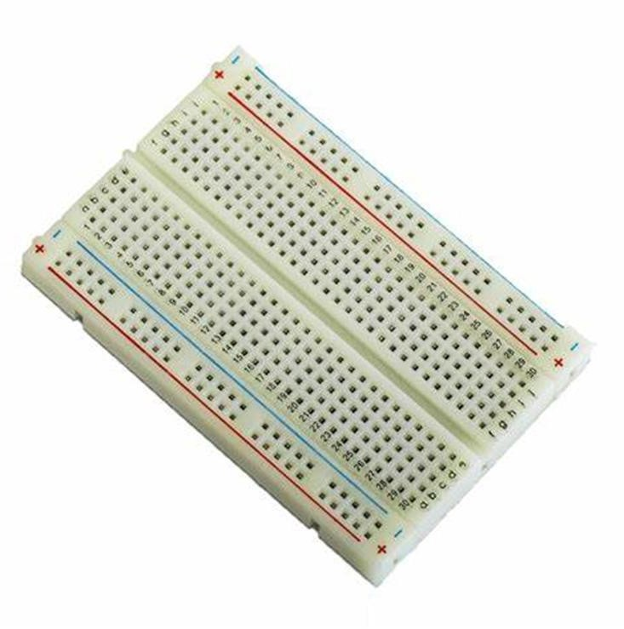 (Bread board)

A breadboard is also categorized as a **Solderless board**. It means that the component does not require any soldering to fit into the board.

Thus, we can say that breadboard can be reused. We can easily fit the components by plugging their end terminal into the board. Hence, a breadboard is often called a **plugboard**.

# 2.6 ARDUINO UNO CABLE:

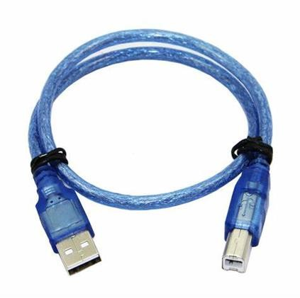 This cable is used to interface any of the Arduino board with you computer, you can also connect your USB printer, scanner, and more to your computer.

(Arduino UNO cable)

**2.7 RELAY:**

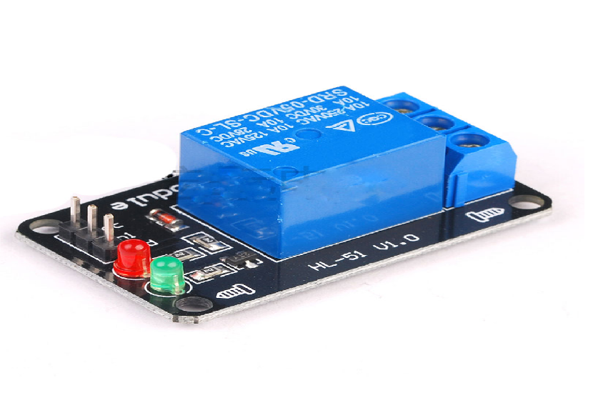A relay is an electromechanical switch that uses an electromagnet to mechanically operate a switch. In the context of an automatic plant watering system, the relay acts as a bridge between the Arduino (or microcontroller) and the water pump. A 5V relay is an electromechanical switch designed to control high-power circuits with a low-power input. Operating with a 5-volt signal, the relay features a coil that, when energized, creates a magnetic field, causing the switch contacts to change states. These relays typically come in different contact configurations, such as normally open (NO) or normally closed (NC), providing flexibility in various applications. With a compact size and compatibility with microcontrollers like Arduino operating at 5V, the 5V relay is widely used in electronics projects, home automation, and industrial applications. It serves as a crucial interface between low-power control systems and higher-power devices, enabling seamless automation and control with the ease of a 5-volt input.

(Relay)

**2.8 5V SUBMERSIBLE WATER PUMP:**

A 5V submersible water pump is a compact and versatile device designed for underwater use in various applications, particularly in projects where a low voltage power source is preferred. The "5V" specification indicates that the pump operates on a voltage of 5 volts, making it suitable for integration with microcontrollers like Arduino or Raspberry Pi, commonly used in DIY electronics projects.

These pumps are often submersible, meaning they can be fully immersed in water, making them ideal for applications such as automatic plant watering systems, aquariums, water fountains, and small-scale hydroponic setups. The submersible design simplifies installation and enables discreet placement within water reservoirs.

Features of a 5V submersible water pump may include a compact size, a low noise level, and the ability to deliver a consistent flow of water. They are typically equipped with a power cable for connection to the power source and may come with different nozzle attachments to control the water flow pattern.

(5V Submersible water Pump)



It's important to note that the selection of a submersible water pump should align with the specific requirements of the intended application, including factors such as flow rate, lift height, and compatibility with the power source. Additionally, proper precautions should be taken to ensure the pump is suitable for the type of water it will be in contact with, and any electrical connections are secure to prevent accidents or damage.

The incorporation of a submersible water pump in an automatic watering system enhances efficiency and precision in delivering water to plants. Submersible pumps, designed to be immersed in water, are well-suited for this application as they efficiently draw water from a reservoir and deliver it directly to the root zone. Their submerged nature minimizes priming concerns, and their compact design allows for discreet placement within the water source. In an automatic watering system, the submersible pump, controlled by a microcontroller such as Arduino, activates based on soil moisture levels, ensuring plants receive the right amount of water at the right time.

**2.9 16*2 LCD DISPLAY**

The "16x2" indicates the size of the display in terms of the number of characters it can show. Specifically, it has 16 columns and 2 rows of characters, making it capable of displaying 16 characters per line and having 2 lines. These displays can typically show alphanumeric characters, symbols, and some custom characters. Each character is usually made up of a 5x8 pixel matrix. They are commonly interfaced with microcontrollers or other devices using a parallel interface or through serial communication protocols like I2C (Inter-Integrated Circuit) or SPI (Serial Peripheral Interface).

16x2 LCD displays are often used in a variety of electronic projects, such as digital thermometers, clocks, small information displays, and more. They are simple and cost-effective for providing basic visual feedback in electronic systems. Many 16x2 LCDs come with a built-in backlight, making them readable in low-light conditions. Power Requirements: They typically operate at a low voltage (often 5V) and consume a relatively small amount of power.

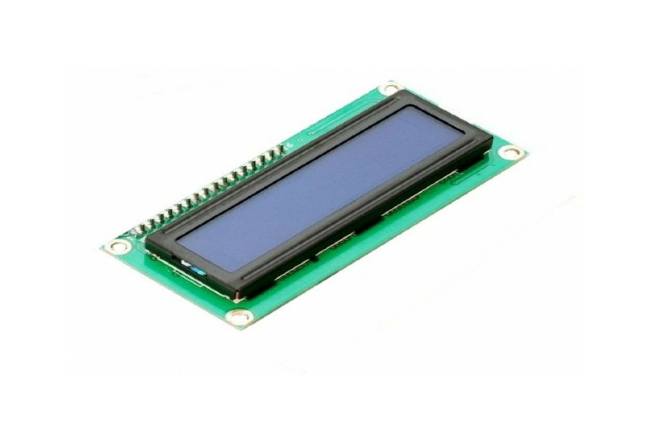 (16*2 LCD Display)

**PROJECT DESCRIPTION**

**PROJECT DESCRIPTION**

### **Components connection:**

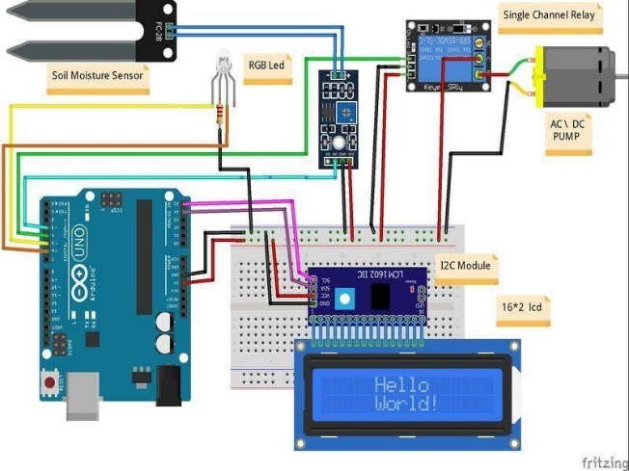

(circuit diagram)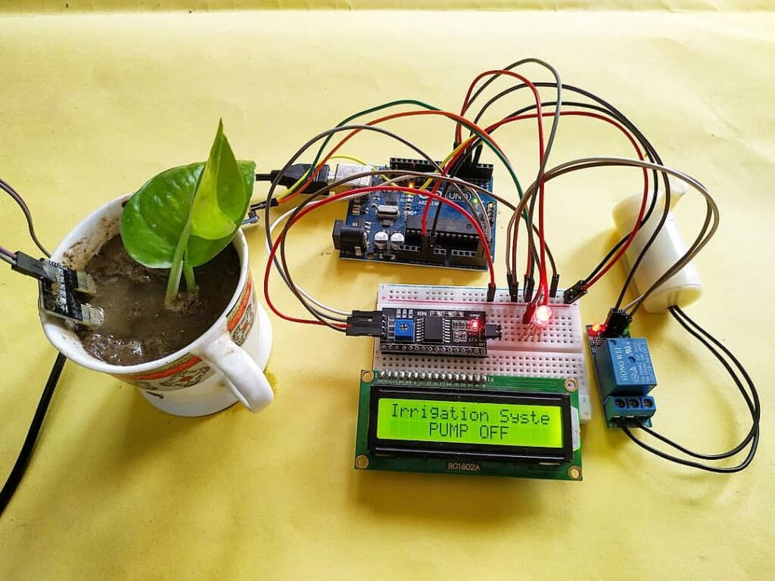

(circuit diagram after connecting)

### **Flash the Arduino UNO**

Connect the Arduino Uno to the computer using Uno cables.

• Ensure the appropriate COM port is selected in the Arduino IDE.

• Choose 'Arduino Uno' as the target board.

• Click the upload button to transfer your code to the Arduino Uno.

This innovative project introduces an affordable and user-friendly solution for automatic plant watering utilizing Arduino Uno technology. By repurposing E-Wastes, this eco-friendly initiative offers a cost-effective way for plant enthusiasts to maintain optimal soil moisture levels. The Arduino Uno, equipped with soil moisture sensors, efficiently detects the soil's hydration status. When the moisture level drops below a predefined threshold, the Arduino triggers a water pump to provide the necessary hydration for the plants.

This device is designed to simplify plant care, making it accessible to individuals at a low cost. Unlike other products in the market, this Arduino Uno-based system relies on straightforward coding, soil moisture sensors, and a water pump. The affordability and simplicity of this project set it apart, demonstrating that advanced technology is not a prerequisite for effective plant care. This automated watering system is user-friendly, making it an ideal solution for both novice and experienced gardeners seeking an economical and efficient approach to plant nurturing.

**Additional Details:**

● Light weight and portable device.

● Easy to use, user friendly.

● Cheap in price.

**Diagram and Processing:**

The automatic plant watering system comprises three integral components seamlessly interconnected for efficient plant care: the soil moisture sensing module, the processing unit, and the watering mechanism.

The soil moisture sensing module is equipped with sensors to gauge the moisture levels in the soil. This module interfaces with the processing unit, which includes a control module. The control unit manages the soil moisture sensors, collecting data about the plant's hydration status.

The processing unit processes this information, determining whether the soil moisture falls below a predefined threshold. When necessary, the control unit activates the watering mechanism, ensuring the plant receives adequate hydration. The watering mechanism can be a pump that delivers water to the plant when triggered by the control unit.

A power supply provides the necessary energy to the central processing unit, ensuring the continuous operation of the system. This integrated setup, utilizing soil moisture sensors, a control module, and a watering mechanism, allows for automated and precise plant care. The system's design prioritizes simplicity and efficiency, making it an accessible solution for plant enthusiasts seeking an automated watering system.

## 4. WORKING PRINCIPLES

The automatic plant watering system operates on a set of principles designed to efficiently monitor and maintain soil moisture levels. The key components include soil moisture sensors, a processing unit (Arduino), and a water pump. Here's a breakdown of the working principles:

**Soil Moisture Sensing:**

Soil moisture sensors, typically inserted into the soil near the plant roots, measure the moisture content of the soil. These sensors can be resistive or capacitive, and their electrical properties change based on the soil's moisture level.

**Processing Unit (Arduino):**

An Arduino microcontroller serves as the processing unit. It reads the analog signals from the soil moisture sensors and converts them into digital data. The Arduino is programmed with a set threshold for soil moisture, determining when the plants require watering.

**Decision Making:**

The Arduino compares the sensor readings with the predefined moisture threshold. If the soil moisture falls below the set level, indicating the need for watering, the Arduino activates the water pump.

**Water Pump Activation:**

The water pump, connected to a water reservoir, is activated by the Arduino to deliver water to the plant. The pump remains on for a specified duration to ensure adequate watering.

**Power Supply:**

The system is powered by a suitable power supply that provides the necessary energy for the Arduino and the water pump to function.

**Automation and Efficiency:**

This automated process ensures that the plants receive water precisely when needed, preventing both overwatering and underwatering. The system's efficiency lies in its ability to respond to real-time soil moisture conditions, promoting optimal plant growth.

**User-Friendly Design:**

The system is designed to be user-friendly, with simple programming and minimal components. This makes it accessible for both novice and experienced gardeners, offering a cost-effective and efficient solution for plant care.

**Uploading the program to Arduino uno:**

After completing all the process of when we upload the program to arduino Uno.

When uploading the program to Arduino the Arduino uno cable is mandatory to connect the computer device to Arduino Uno.

After the connection we can check the board whether Arduino uno is selected or not, if it’s not selected select the board on board manager.

Check the port, port will display error when given wrong port is given.

After the process we can upload the program into Arduino and check if any error occurs or not, if any error occurs clear that error and run the code and upload the program

##### RESULT AND OUTPUT

**RESULT**

The output of the given program:

Once code can be uploaded in arduino

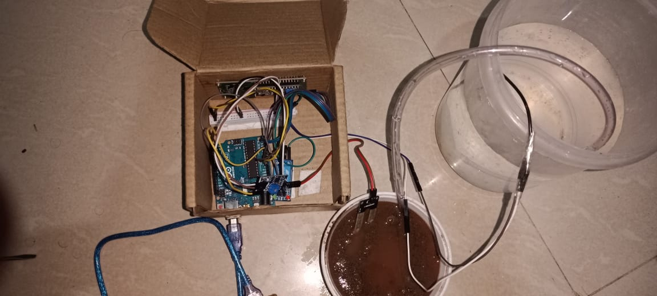

**SOURCE CODE**

**Source code**

#include <Wire.h>

#include <LiquidCrystal_I2C.h>

LiquidCrystal_I2C lcd(0x27, 16, 2); // Set the LCD address and dimensions

const int moistureSensorPin = A0;

const int pumpControlPin = 2;

const int moistureThreshold = 500;

// Adjust this value based on your soil and plant needs

void setup() {

lcd.begin(16, 2);

lcd.setCursor(0, 0); // Set cursor to the beginning of the first line

lcd.print("Plant Watering"); // Display the title

lcd.setCursor(0, 1); // Move to the second line

lcd.print("System"); // Display the subtitle

delay(2000); // Display the title for 2 seconds

lcd.clear(); // Clear the display before entering the loop

pinMode(moistureSensorPin, INPUT);

pinMode(pumpControlPin, OUTPUT);

}

void loop() {

int moistureLevel = analogRead(moistureSensorPin);

lcd.setCursor(0, 0);

lcd.print("Moisture: ");

lcd.print(moistureLevel);

lcd.setCursor(0, 1);

lcd.print("Threshold: ");

lcd.print(moistureThreshold);

if (moistureLevel < moistureThreshold) {

digitalWrite(pumpControlPin, HIGH); // Activate the water pump

delay(5000); // Run the pump for 5 seconds (adjust as needed)

digitalWrite(pumpControlPin, LOW); // Turn off the water pump

}

delay(1000);

}

**CONCLUSION**

**CONCLUSION**

The development and implementation of the automatic plant watering system mark a significant step towards efficient and sustainable plant care. This project aimed to address the challenges associated with manual watering by introducing an automated solution using Arduino technology and soil moisture sensors. The automatic plant watering system effectively optimizes the watering process by continuously monitoring soil moisture levels. This ensures that plants receive water precisely when needed, preventing both overwatering and under watering scenarios.

The use of readily available components, such as Arduino Uno, soil moisture sensors, and a water pump, makes the system cost-effective and accessible. This affordability encourages wider adoption among gardening enthusiasts. With the automatic plant watering system, the maintenance burden associated with manual monitoring and watering is significantly reduced.

This enhances the overall efficiency of plant care, particularly in scenarios where regular attention might be challenging. In conclusion, the automatic plant watering system successfully combines technology and plant care, offering a practical and accessible solution for individuals seeking an efficient, cost-effective, and environmentally friendly approach to nurturing their plants.

**REFERENCE**

**REFERENCE**

**Webpage link:**

1. [**https://www.sciencebuddies.org/science-fair-projects/project-ideas/PlantBio_p055/plant-biology/arduino-automatic-plant-watering**](https://www.sciencebuddies.org/science-fair-projects/project-ideas/PlantBio_p055/plant-biology/arduino-automatic-plant-watering)
2. [**https://www.researchgate.net/publication/348625964_INTERNET_OF_THINGS_AUTOMATIC_PLANT_WATERING_SYSTEM_USING_ANDROID**](https://www.researchgate.net/publication/348625964_INTERNET_OF_THINGS_AUTOMATIC_PLANT_WATERING_SYSTEM_USING_ANDROID)

**Books:**

1. Arduino Sun Tracking, Robotic Arm, Cell Phone Controlled Robot Car, Propeller Drove Show, Automatic Plant Irrigation Interesting Projects for Future Enhancement

By authors :[Ambika Parameswari K](https://www.google.co.in/search?hl=ta&q=inauthor:%22Ambika+Parameswari+K%22&tbm=bks&sa=X&ved=2ahUKEwiQlY_Ck_WCAxUExzgGHYQDA6kQmxMoAHoECBIQAg&sxsrf=AM9HkKnwZJXZGpPyxUrw6Ho1vv1oy0MChw:1701671281779), [Anbazhagan K](https://www.google.co.in/search?hl=ta&q=inauthor:%22Anbazhagan+K%22&tbm=bks&sa=X&ved=2ahUKEwiQlY_Ck_WCAxUExzgGHYQDA6kQmxMoAXoECBIQAw&sxsrf=AM9HkKnwZJXZGpPyxUrw6Ho1vv1oy0MChw:1701671281779)